Deep Learning
3. Autoencoders: Unsupervised Learning
3.1 Introduction, Linear Autoencoder, Undercomplete Autoencoder, Overcomplete Autoencoders, Regularization in Autoencoders.
3.2 Denoising Autoencoders, Sparse Autoencoders, Contractive Autoencoders.
3.3 Application of Autoencoders: Image Compression.
PAST QUESTIONS:
- Explain denoising auto encoder model. (D23)
- What are Undercomplete Autoencoders? (M24)
- Explain main components of an Autoencoder and it`s architecture. (M24)
- Explain any three types of Autoencoders. (M24, D24)
- What are Denoising Autoencoders? (D24)
- Explain the working of auto encoders. Also discuss type of auto encoders in detail. (M25)

NOTES:

*Autoencoders :-
Autoencoders are a special type of neural networks that learn to compress data into a compact form and then reconstruct it to closely match the original input. They consist of an:
- Encoder that captures important features by reducing dimensionality.
- Decoder that rebuilds the data from this compressed representation.
An autoencoder’s architecture consists of three main components that work together to compress and then reconstruct data which are as follows:

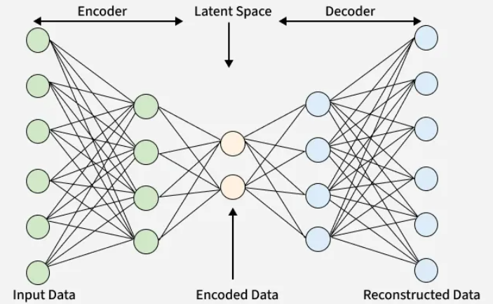
1. Encoder: It compress the input data into a smaller, more manageable form by reducing its dimensionality while preserving important information. It has three layers which are:
- Input Layer: This is where the original data enters the network. It can be images, text features or any other structured data.
- Hidden Layers: These layers perform a series of transformations on the input data. Each hidden layer applies weights and activation functions to capture important patterns, progressively reducing the data's size and complexity.
- Output (Latent Space): The encoder outputs a compressed vector known as the latent representation or encoding. This vector captures the important features of the input data in a condensed form.
2. Bottleneck (Latent Space): It is the smallest layer of the network which represents the most compressed version of the input data. It serves as the information bottleneck which force the network to prioritize the most significant features. This compact representation helps the model learn the underlying structure and key patterns of the input helps in enabling better generalization and efficient data encoding.
3. Decoder: It is responsible for taking the compressed representation from the latent space and reconstructing it back into the original data form.
- Hidden Layers: These layers progressively expand the latent vector back into a higher-dimensional space. Through successive transformations decoder attempts to restore the original data shape and details
- Output Layer: The final layer produces the reconstructed output which aims to closely resemble the original input. The quality of reconstruction depends on how well the encoder-decoder pair can minimize the difference between the input and output during training.

*Types of Autoencoders :-
1. Denoising Autoencoders: Denoising Autoencoders (DAEs) are a special type of autoencoder designed to handle corrupted or noisy input data. Their primary goal is to reconstruct the clean, original input from a deliberately noisy version of it.
During training, random noise is added to the input data, and the autoencoder is trained to minimize the reconstruction error between the original clean data and the output produced by the model. By learning to remove noise and recover the true signal, the model captures robust and meaningful features that are invariant to noise.
This process enables Denoising Autoencoders to improve generalization, making them highly effective for feature extraction, image denoising, and data compression tasks.
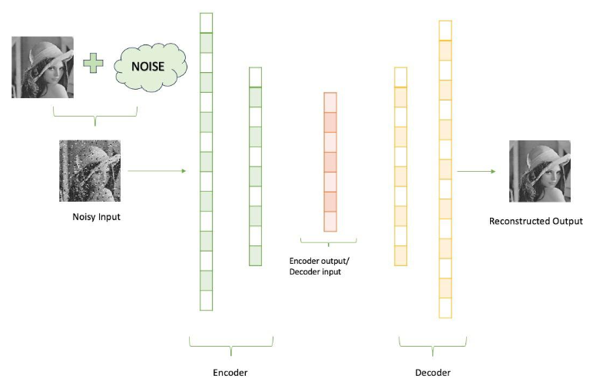

2. Sparse Autoencoders: Sparse autoencoders are a specific form of autoencoder that's been trained for feature learning and dimensionality reduction.
As opposed to regular autoencoders, which are trained to reconstruct the input data in the output, sparse autoencoders add a sparsity penalty that encourages the hidden layer to only use a limited number of neurons at any given time. The sparsity penalty causes the model to concentrate on the extraction of the most relevant features from the input data.
They include regularization methods like L1 penalty and dropout to enforce sparsity.
This selective activation helps in feature selection and learning meaningful patterns while ignoring irrelevant noise.
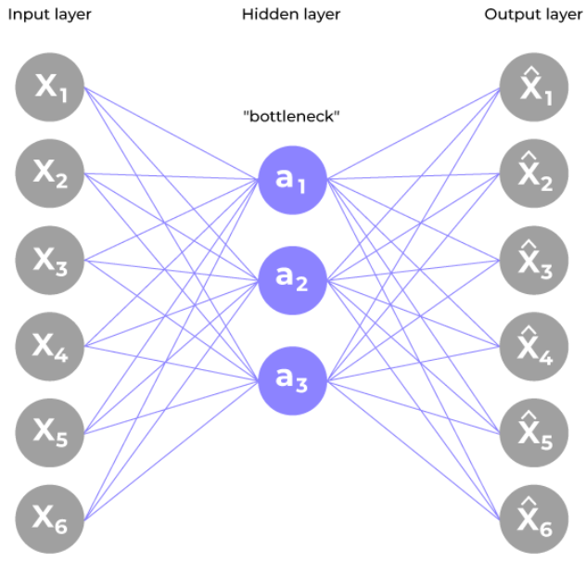

3. Contractive Autoencoders: A Contractive Autoencoder (CAE) is a type of regularized autoencoder designed to learn robust and stable feature representations by making the encoder less sensitive to small changes in the input data.
In order to achieve this we must add a regularizer or penalty term to the cost function that the encoder is trying to minimize.
Unlike traditional autoencoders that only minimize reconstruction error, a Contractive Autoencoder adds an additional regularization term to its loss function.
CAE prevents overfitting and enhances model generalization making CAEs especially powerful for tasks requiring robust feature learning.

*Linear Autoencoder :-
A linear autoencoder is a type of neural network that uses a linear encoder and a linear decoder to learn a compressed representation of input data. It is trained to minimize the mean squared error between the original input and the reconstructed output.
Unlike non-linear autoencoders, linear ones are simpler and can be used for feature extraction and dimensionality reduction, though they are less powerful for complex data.

*Undercomplete Autoencoder :-
An Undercomplete Autoencoder is a type of autoencoder where the dimension of the hidden layer (latent representation) is smaller than the dimension of the input data.
It is termed "undercomplete" because it forces the representation to have a lower dimensionality than the input itself, thereby learning to capture only the most essential features.
The goal of this architecture is not just to copy the input to the output, but to learn the most important features that can effectively represent the data in a compressed form.

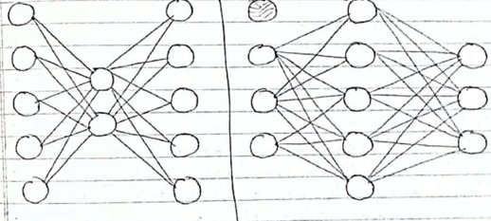

*Overcomplete Autoencoder :-
An Overcomplete Autoencoder is a type of autoencoder in which the dimension of the hidden (latent) layer is greater than the dimension of the input data.
This means that the encoder and decoder layers have more units than the input layer.
Unlike an undercomplete autoencoder that compresses data, an overcomplete one has more neurons in the hidden layer, allowing it to capture more detailed features of the input.
The idea behind using more hidden units is to learn a more complex, non-linear function that can better capture the structure of the data.



